ST10326084  
DEAN GIBSON

DBAS ASSIGNMENT 1

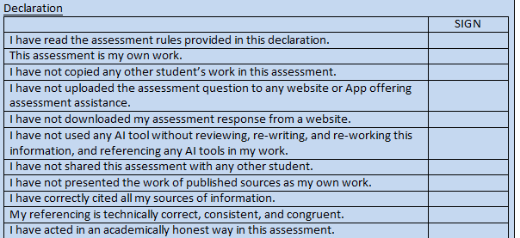



Instructions:

Open in word (on the desktop to ensure everything is viewed as intended.

Documents will be posted in a github repository.

<https://github.com/ST-10326084/DBAS-Assignment-1>

**Question 1**

<https://www.canva.com/design/DAF_mgQZsHQ/Z5rkuPyxWq3crtKFANoGEA/view?utm_content=DAF_mgQZsHQ&utm_campaign=designshare&utm_medium=link&utm_source=editor>

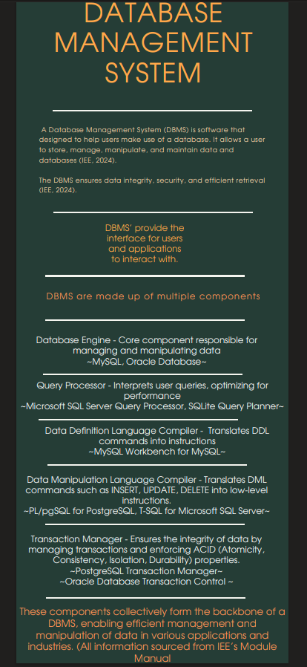

Question 2

2.1) For information such as data about courses, where many aspects and details are important such as names, and categories using a relational database would be most appropriate (Ibm, 2024).

* The data is structured with well-defined relationships between each of the entities like the course name, category, and creator’s name (ibm, 2024).
* This information is easily captured in tables, where we can use primary and foreign keys to further establish relationships between the information (ibm, 2024).
* Performing queries involving joins across tables is straightforward using SQL, this is the language used to relational databases (ibm, 2024).
* Relational databases excel when handling with structured data with fixed data (ibm, 2024).

2.2) For video, images and files, this media is quite different to traditional data and cannot be stored in tables as its unstructured data and thus using NoSQL databases would be most appropriate (Amazon Web Services, Inc., 2024).

* Media such as videos, and files particularly have large file sizes, and are unstructured (Amazon Web Services, Inc., 2024).
* NOSQL databases are flexible, and they can accept all types of data formats, so when working with video where a file can be stored in various file formats this is crucial (mp4, Avi etc) (Amazon Web Services, Inc., 2024).
* Efficient storage of individual media files because complex joins are not needed (Amazon Web Services, Inc., 2024).
* Scaling storage is easier with NoSQL than with SQL, as the data volume grows with more courses (Amazon Web Services, Inc., 2024).

**Question 3**

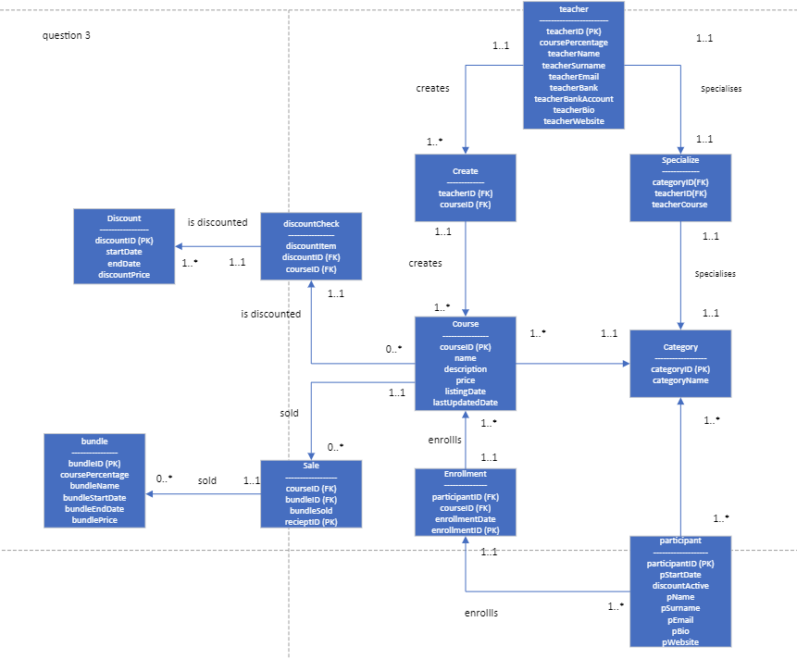

**Question 4**

Thato’s original ERD

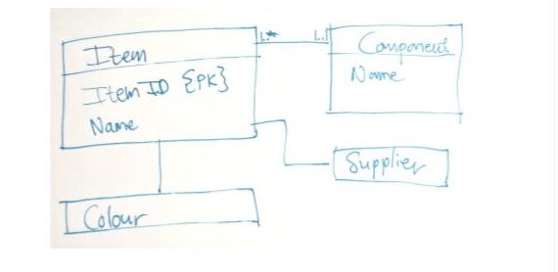

Tips (IEE, 2024):

1. More descriptive names to suggest what you are referring to, example compName or componentName instead of name.
2. Add in multiplicities to indicate the relationship.
3. Add in a directional arrow to indicate the flow of the database.
4. Include PK or primary keys at every entity.
5. Make use of a bridge to account for many to many relationships.
6. Include relationship names to ensure user understands what they are looking at.
7. Include all variables referred to in the prompt, such as quantity.
8. Use UML notation for the whole ERD, as seen in item entity.
9. Ensure that variables and entities follow the same casing structure, whether is camal casing or some alternative.
10. Finally, ensure that the diagram is neat and organised.

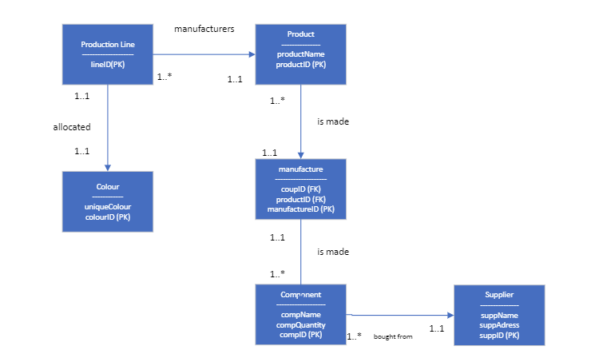My improved version



# References

IEE, 2024. *DBAS MODULE MANUAL.* [Online]   
Available at: https://advtechonline.sharepoint.com/sites/TertiaryStudents/IIE%20Student%20Materials/New%20Student%20Materials%20CAT/DBAS6211/2024/DBAS6211MM.pdf?CT=1710525562041&OR=ItemsView   
[Accessed 15 MAY 2024].

Ibm. (2024). *What is a relational database? | IBM*. [online] Available at: https://www.ibm.com/topics/relational-databases

[Accessed 20 Mar. 2024].

‌

Amazon Web Services, Inc. (2024). *Which NoSQL database is right for you?* [online] Available at: https://aws.amazon.com/nosql/#:~:text=NoSQL%20databases%20use%20a%20variety,consistency%20restrictions%20of%20relational%20databases.

[Accessed 20 Mar. 2024].

‌